**Matter:**

Matter is defined as, any substance that has mass and occupies space. All physical objects are composed of matter, in the form of atoms, which are in turn composed of protons, neutrons, and electrons.

**Atom:**

An atom is the smallest particle of an element that retains the characteristics of that element. Each element in the periodic table has a unique atomic structure. According to the classical Bohr model, atoms have a planetary type of structure that consists of a central nucleus surrounded by orbiting electrons, as illustrated in Figure 1-1. The nucleus consists of positively charged particles called protons, uncharged (neutral) particles called neutrons and negatively charged particles known as electrons.

**Atomic Number:**

All elements are arranged in the periodic table of the elements in order according to their atomic number. The **atomic number** equals the number of protons in the nucleus, which is the same as the number of electrons in an electrically balanced (neutral) atom. For example, Hydrogen has an atomic number of 1 and helium has an atomic number of 2. In their normal

(or neutral) state, all atoms of a given element have the same number of electrons as protons; the positive charges cancel the negative charges, and the atom has a net charge of zero.

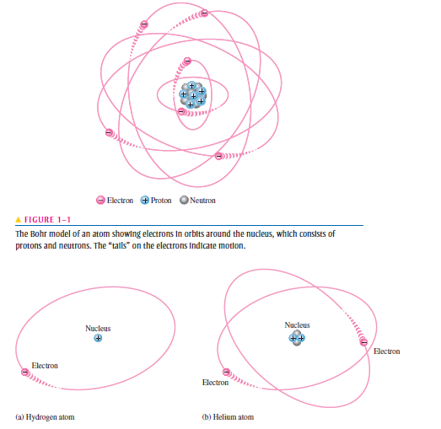

**Electrons and Shells:**

**Energy Levels:**Electrons orbit the nucleus of an atom at certain distances from the nucleus. Electrons near the nucleus have less energy than those in more distant orbits. Each discrete distance (**orbit**) from the nucleus corresponds to a certain energy level. In an atom, the orbits are grouped into energy levels known as **shells**. A given atom has a fixed number of shells. Each shell has a fixed maximum number of electrons. The shells (energy levels) are designated 1, 2, 3, and so on, with 1 being closest to the nucleus.

**The Maximum Number of Electrons in Each Shell:** The maximum number of electrons(*Ne*) that can exist in each shell of an atom can be calculated by the formula,

***Ne*=2n2**

where n is number of shell. the maximum number of electrons that can exist in the inner most shell

(shell 1) is

***Ne* = 2n2 =2(1)2 =2**

The maximum number of electrons that can exist in shell 2 is

***Ne* = 2n2 =2(2)2 =8**

The maximum number of electrons that can exist in shell 3 is

***Ne* = 2n2 =2(3)2 =18**

The maximum number of electrons that can exist in shell 4 is

***Ne* = 2n2 =2(4)2 =32**

**Valence Electrons:**

Electrons that are in orbits farther from the nucleus have higher energy and are less tightly bound to the atom than those closer to the nucleus. This is because the force of attraction between the positively charged nucleus and the negatively charged electron decreases with increasing distance from the nucleus. Electrons with the highest energy exist in the outermost

shell of an atom and are relatively loosely bound to the atom. This outermost shell is known as the valenceshell and electrons in this shell are called valence electrons.These valence electrons contribute to determine its electrical properties. When a valence electron gains sufficient energy from an external source, it can break free from its atom. This is the basis for conduction in materials.

**Ionization:**

When an atom absorbs energy from a heat source or from light, for example, the energies of the electrons are raised. The valence electrons possess more energy and are more loosely bound to the atom than inner electrons, so they can easily jump to higher energy shells when external energy is absorbed by the atom.

If a valence electron acquires a sufficient amount of energy, called *ionization energy,* it can actually escape from the outer shell and the atom’s influence. The departure of a valence electron leaves a previously neutral atom with an excess of positive charge (more protons than electrons). The process of losing a valence electron is known as **ionization**, and the resulting positively charged atom is called a **positive ion (cation).**

For example, the chemical symbol for hydrogen is H. When a neutral hydrogen atom loses its valence electron and becomes a positive ion, it is designated H_. The escaped valence electron is called a **free electron**.

The reverse process can occur in certain atoms when a free electron collides with the atom and is captured, releasing energy. The atom that has acquired the extra electron is called a **negative ion (anion).**

**Classification of Matter on the basis of semi-conductor theory:**

All materials are made up of atoms. These atoms contribute to the electrical properties of a material, including its ability to conduct electrical current.

**Insulators:** An **insulator** is a material that does not conduct electrical current under normal conditions. Valence electrons are tightly bound to the atoms; therefore, there are very few free electrons in an insulator. Examples of insulators are rubber, plastics, glass etc.

**Conductors:** A **conductor** is a material that easily conducts electrical current. Most metals are good conductors. The best conductors are single-element materials, such as copper (Cu), silver (Ag), gold (Au), and aluminum (Al), which are characterized by atoms with only one valence electron very loosely bound to the atom. These loosely bound valence electrons become free electrons. Therefore, in a conductive material the free electrons are valence electrons.

**Semiconductors:** A **semiconductor** is a material that is between conductors and insulators in its ability to conduct electrical current. A semiconductor in its pure (intrinsic) state is neither a good conductor nor a good insulator. Single-element semiconductors are antimony (Sb), arsenic (As), boron (B), silicon (Si), and germanium (Ge). Compound semiconductors such as gallium arsenide, indium phosphide, gallium nitride, silicon carbide, and silicon germanium are also commonly used. Silicon is the most commonly used semiconduct

**Energy band:**

The valence shell of an atom represents a band of energy levels and that the valence electrons are confined to that band. When an electron acquires enough additional energy, it can leave the valence shell, become a *free electron,* and exist in what is known as the **conduction band.**

The difference in energy between the valence band and the conduction band is called an **energy gap** or **band gap***.* This is the amount of energy that a valence electron must have in order to jump from the valence band to the conduction band. Once in the conduction band, the electron is free to move throughout the material and is not tied to any given atom.

For insulators, the gap can be crossed only when breakdown conditions

occur—as when a very high voltage is applied across the material. The band gap is illustrated in Figure 1–2(a) for insulators.

In semiconductors the band gap is smaller, allowing an electron in the valence band to jump into the conduction band if it absorbs a photon. The band gap depends on the semiconductor material. This is illustrated in Figure 1–2(b).

In conductors, the conduction band and valence band overlap, so there is no gap, as shown in Figure 1–2(c). This means that electrons in the valence band move freely into the conduction band, so there are always electrons available as free electrons.

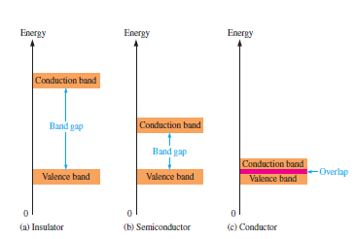

**Figure 1-2**